Artist Books as Personal Therapy

A November 30, 2022, presentation at the University of Puget Sound as part of
Toward a Just Memory: Resistance, Violence, Art and the American War in Vietnam
By Peter Newland, Specialist 5th Class U.S. Army Retired.

Thank you, Professor Bristow, for your warm welcome, and Good Afternoon everyone. I’m pleased to be here to share some memories of Vietnam and how my 13 months in country influenced my world view, my work as a book artist and the creation Bui Doi and Did You See What I Saw, two books we’ll examine in just a bit.

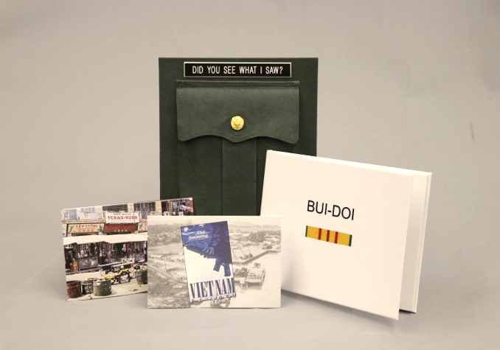

I hold the view that every soldier’s experience is unique, that memory is fungible, that you should not be a stranger to hard work, but never discount the influence of chance and luck on the course your life will take.

To provide some context for my Vietnam books, let me begin by briefly sharing some personal history. I was born in 1944, two weeks before Christmas and about 8 months before America dropped Atomic Bombs on Hiroshima and Nagasaki and WW II ended. I grew up in a construction family and went through the grades in Everett, WA.

In September 1963 I matriculated at Whitman College in Walla Walla, WA. On November 22nd I walked across Ankeny Field to the Student Union Building to pick up my mail and found my classmates huddled in front of a TV, tears streaming as Walter Cronkite explained that our 35th President, John F. Kennedy, had been assassinated. It was what you might call my first loss of innocence.

I graduated from Whitman in June 1967 with an unusual double major in Theatre and Economics and immediately headed to Dartmouth College for summer stock and then on to New York University to pursue my MFA in Theatrical Management. In June of 1968 I married my first wife, Elizabeth, and we returned to Staten Island where we both had jobs. Around Christmas, my draft notice arrived. My report date was extended to allow me to complete my MFA. Then we packed the car and drove cross-country with our cat Sherman, stopping along the way to visit Yellowstone National Park.

I was inducted into the United States Army on 9 July 1969. My basic training was at Fort Lewis. To my relief, my advanced training was at Fort Eustice, Virginia in Transportation Movements Control. My assigned MOS was 71N20. I was home for a tense and worrisome Christmas in 1969 before my flight to Guam and then on to Tan Son Nhut Airport in Saigon.

I then spent 12 months and 19 days (but who’s counting?) assigned to the 4th Headquarters Transportation Corp, first in the heart of Saigon at Camp Davies and then 20 miles north at Long Binh, the largest and perhaps best protected military installation in all of Vietnam.

My original orders had me scheduled to go to Cat Lai, a much more dangerous place. Luck and chance intervened.

I know from the syllabus that you have been exposed to a great deal about the war and efforts to end it. I suspect you know that nearly 2,700,000 Americans served there from when Truman’s Administration was supporting the efforts of the colonial French government, through Gerald Ford’s time when Saigon collapsed. There are a lot of different stories and viewpoints. It has been said that the first casualty of the Vietnam War was “Truth”. You won’t get any argument out of me. It was a very sad and tragic time and certainly supports the notion that arrogance is a universal and permanent human problem.

So, what is an artists’ book?

That is a complex question that the field is constantly debating. Luckily you have a great resource at hand here at the Collins in special collections where there is a fine and growing number of artists’ books. I recommend you avail yourself of the opportunity to explore the collection.

In some ways you might think of artists’ books as examples of what Marshall McLuhan meant by his famous phrase, “The medium is the message”. And despite the metaphorical phrase “don’t judge a book by its cover” WE DO and nowadays every bookstore has changed their displays, so the cover is the first thing you see. The decision to pick or not pick up the book is a “judgment” of which book artists are keenly aware.

Generally, I define artists’ books as limited-edition presentations of original text and image, often in unique formats or structures.

If I may slip in a little promotion, if you’re interested in possibly learning to make your own book, help is close at hand from the Puget Sound Book Artists. We are always looking for new members, conducting classes and other forums. We hold an annual member exhibit here at the library. AND we offer student discounts.

I’ve brought with me a few catalogs and “how to” books which you are free to peruse. They should give you a sense of the depth and breath of what is called an artists’ book. You’re welcome to handle all the things I’ve brought but please do not do so while eating a peanut butter and jelly sandwich. Compared to Robyn and me, archivists are (as they should be) much more conservative about how the materials in their care may be handled.

To see a book behind glass is an entirely different experience than holding it in your hands. That is why, over the years, Robyn and I have made it a priority to have some artist books on our shelves. And we always justify the expense by claiming they are models for something we might do some day and part of our commitment to support artists.

So let me begin by showing you two books that inspire us.

The first is Despatches from Michael Katakis produced by Foolscap Press in 2008. Three simple chapbooks about travel in Greece, Morocco and Sierra Leone with tipped in black and white photos enclosed in a pouch made from handmade Cave Paper called crackle. So simple yet awesomely powerful.
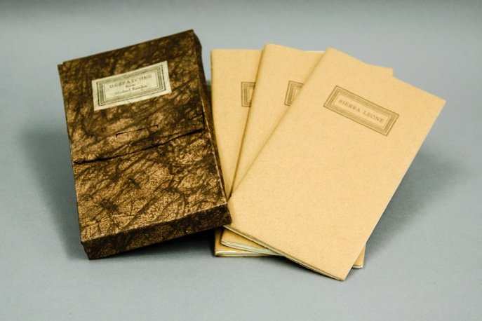

The second is what they call a flag book. Never has there been a structure more perfect for the contents. It is always the goal to meld text and structure, so they reinforce and inform each other. You would be hard pressed to find a better example than Faces of the Fallen by Kristen Gudbrandsdottir. The content is a record of just some of the graves at Arlington National Cemetery of those lost in Afghanistan and Iraq. As Cicero said, “the life of the dead is placed in the memory of the living.”

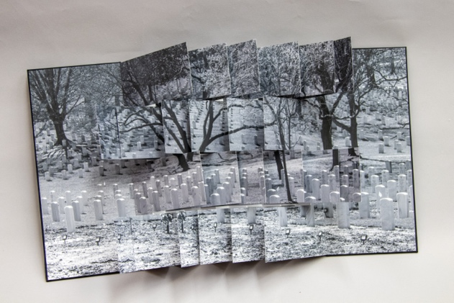

“Those that fail to learn from history are doomed to repeat it.” That phrase or something like it is often attributed to Winston Churchill or Mark Twain. Regardless of the source of the quote, the wars in Afghanistan and Iraq are proof positive of its validity.

So, to be clear, I was never in the mountainous jungle. I was never airlifted into battle. I was what members of the first Airborne, the Calvary, Artillery units and grunts referred to as “REMF”. Rear Echelon Mother ____. I suspect you can fill in the blank.

Now to be certain somebody must make sure those in the heat of battle have the materials they need to keep up the fight. That was the 4th HQ Transportation Corp mission. But, as you might imagine, when exhausted and frightened soldiers returned to places like Long Binh to rest after a treacherous fire fight and the loss of buddies who went home in body bags, they were incensed that some of us were secure in a compound with saloons, libraries, swimming pools, movie theatres, dark rooms and many other amenities. FOR SURE, you did not argue or mess with them.

At Long Binh, each soldier was issued an M-16, ammo, a flak jacket and helmet. We took our turns at guard duty behind multiple fences and acres of razor wire. That said, the only thing I ever shot were pictures. And those were mainly to send home to let Elizabeth know what I was doing, that I still had a sense of humor and was alive as of the date of the post mark The negatives and slides sat in a box in the attic for forty years before I was encouraged to use them to tell this story. The words poured out of me in a single day.

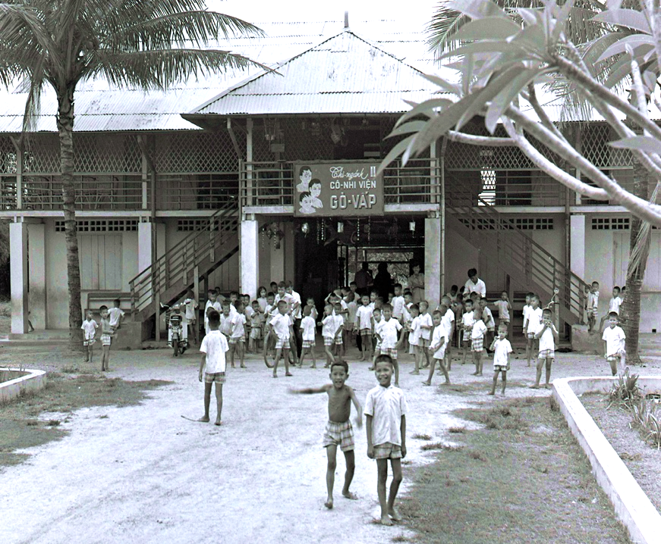

Prologue
The song Bui- Doi opens the second act of Miss Saigon, the twelfth longest running show in Broadway musical history. Bui-Doi roughly translates to “street children”. The song proclaims they are “the dust of life”.

My commanding officer encouraged us to volunteer for “service projects”. I did, using my carpentry skills to help construct a roof over the kitchen patio at Go-Vap Orphanage. There were many orphanages throughout South Vietnam during the war years. Many still exist today. In 1975, after Saigon fell, Vietnam was “reunified” and the city was renamed Hoh Chi Minh City. The new regime ordered all orphanages to burn their records, thus turning to ashes the history of the children who had been helped to survive.

I did not understand the language or much about the children whose photographs are here. But we shared a common bond around survival. I know what has happened to my life. I still wonder what has happened to theirs.

Assignment

Never wanted to go
I was sent
My only similarity with Jesus
Is I’m a carpenter too
Helping construct a roof over the kitchen patio
An act of charity,
Myself the beneficiary

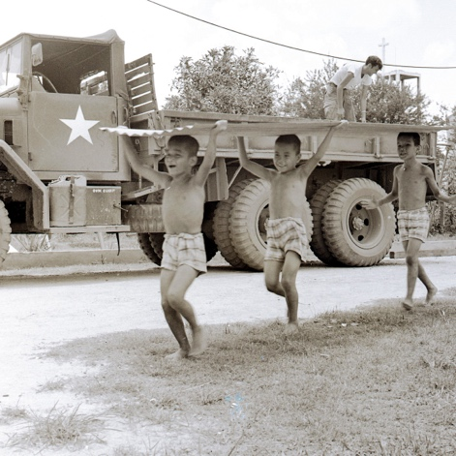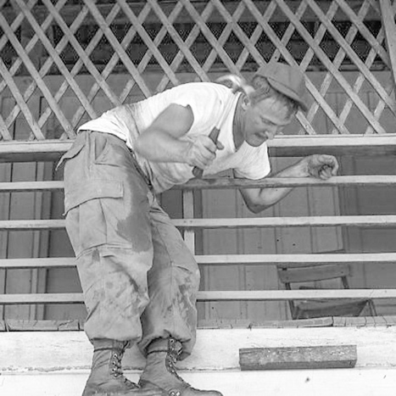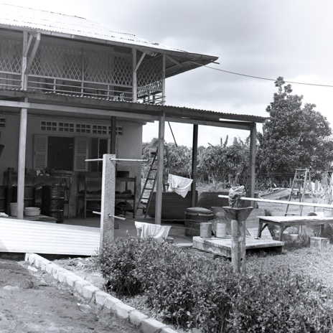

Letting Go

After 40 years I put my trusty old film camera, a Nikkor Nikkormat FTN #3866782, up for adoption. Glazer’s Camera in Seattle bought it for about its original price. They declined my favorite 105 mm lens declaring it “damaged and too hard to repair.” A perfect metaphor for the childhoods it captured.

Those kids were collateral damage with no money down. I’ve kept their pictures in a box and in my memory for decades. Maybe they are why I was sent there—a lesson in humility—a chance to practice gratitude.

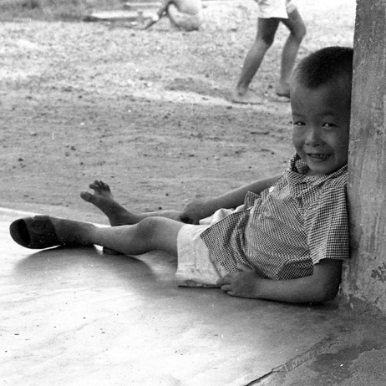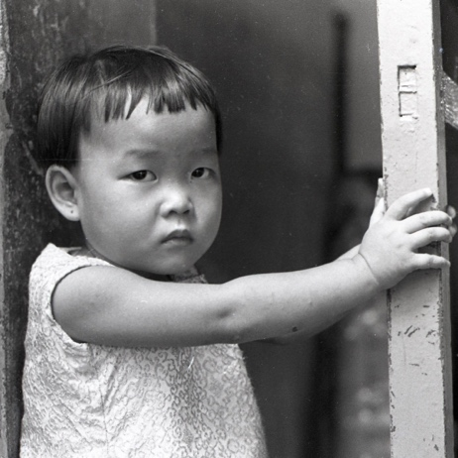

The Question

So, what do we do with what we have collected along the way?
There are people who can help you with your clutter.
For a fee they will straighten up you garage, clear out your attic and sweep clean your basement.
For a fee there are practitioners who will do the same for your head. Help you make sense out of the thoughts you keep tripping over. Some will even work on your aching heart. It is a delicate operation but sometimes they can do amazing things.
And for a fee there are those who will reduce your density to ashes and hand them to your next of kin in a sturdy plastic bag. Virtually no trace of what you did except, except, yeah except what?

Always with me

#782 was my trusty sidekick
Click, click, click
Never forget they are here
Because we were there.
Shame on America, why did we not know better?
Or, worse yet, perhaps we did.
There is no narrative that can really
Describe the experience and I’ll
never really know if my empathy
is what saved me or not.
But I got home with body and mind
pretty much intact. Victory by some
standards and all that was possible
in a war without purpose.

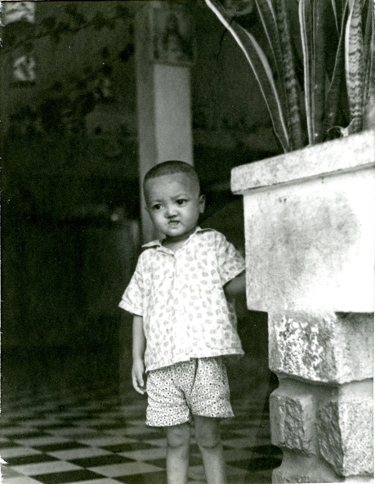

Infinitesimal—
That is the difference you can not see.
So, who knows if what we did changed anything?
I’ve always hoped it might have.

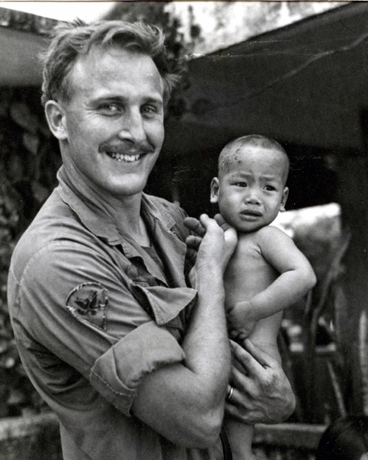

My second Vietnam book, produced in 2016, was a bit of a family affair. Robyn was my printer, and my daughter Jenn sewed the facsimile dress uniform pocket that is a container for 15 picture postcards with snarky captions. The buttons were salvaged from my dress uniform jacket which Elizabeth and I burned not long after I returned home.

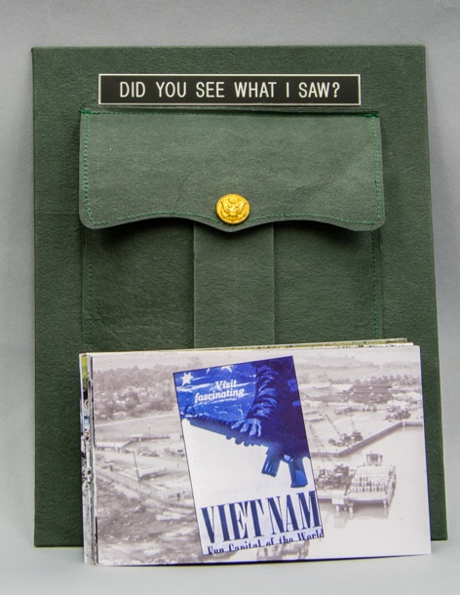

The book’s genesis was a National Geographic advertisement that offended me. Don’t get me wrong, Vietnam is quite beautiful, and I understand why some might wish to visit. But the commercial promotion and obvious profit motive to encourage visits to lush Vietnam to explore the tunnels and villages where Viet Cong once resided and POWs were sometimes held, went too far. It was disrespectful of the ultimate sacrifice of over 58,000 American soldiers. Thus, the birth of “Did You See What I Saw”. The pocket is custom Cave Paper mounted on board with a cover picture from the Commander’s Monthly Review. It was my job to produce the Review and oversee its distribution to Officers throughout the command structure. It detailed tonnage in, tonnage out, tonnage lost etc. Everything was quantified. I never saw the actual manifests, so the reports’ accuracy was suspect. No one ever challenged it and I’m quite certain no one read it carefully. On a few occasions, as a test and small act of defiance, I inserted nonsensical text and obvious arithmetic errors that no one ever questioned.

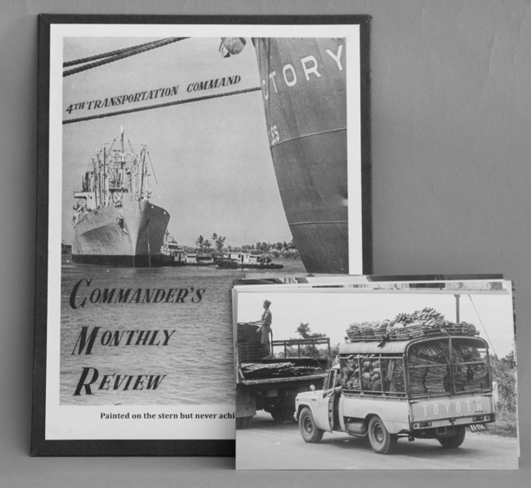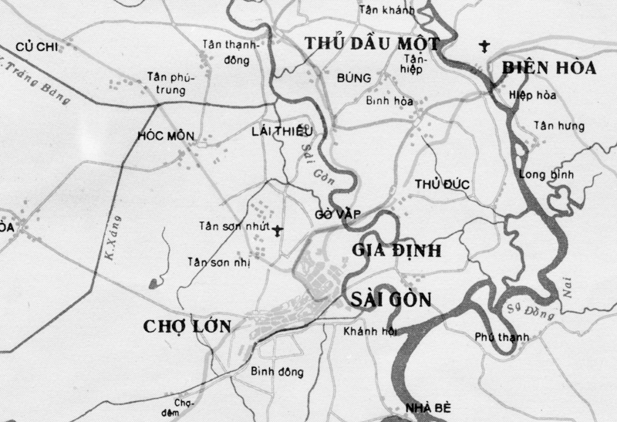

If I may, Let me close with a caution and a suggestion for each of you. Beware of men of inordinate ambition and if, you learn nothing more from your campus experience, learn to ask probing questions. I hope you have some for me.

